PHP Project
Git hub: https://github.com/akshu20791/php-project
Prerquisite:
You need to have your own github account
Process:

- Login to your github account
Open the link : https://github.com/akshu20791/php-project
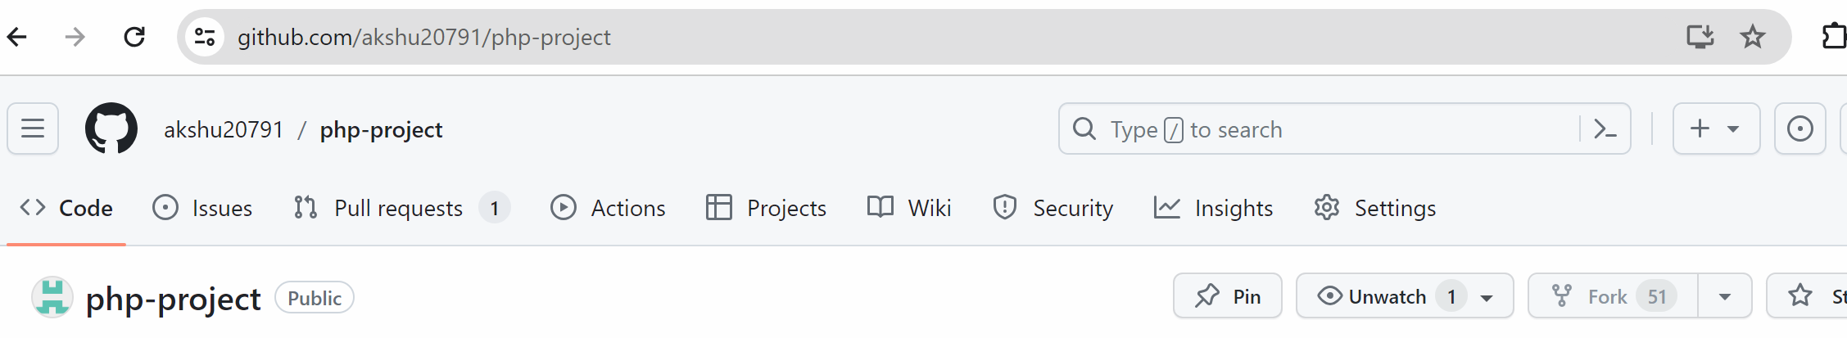

(in my case this button is not visible because I cannot fork to my own repo)
After you fork it ..lets suppose if your github username is sumanthlearner
Then your github link will become like https://github.com/sumanthlearner/php-project
(which means the project would be copied from akshu20791 github to your github accont)

….> Click on Jenkinsfile

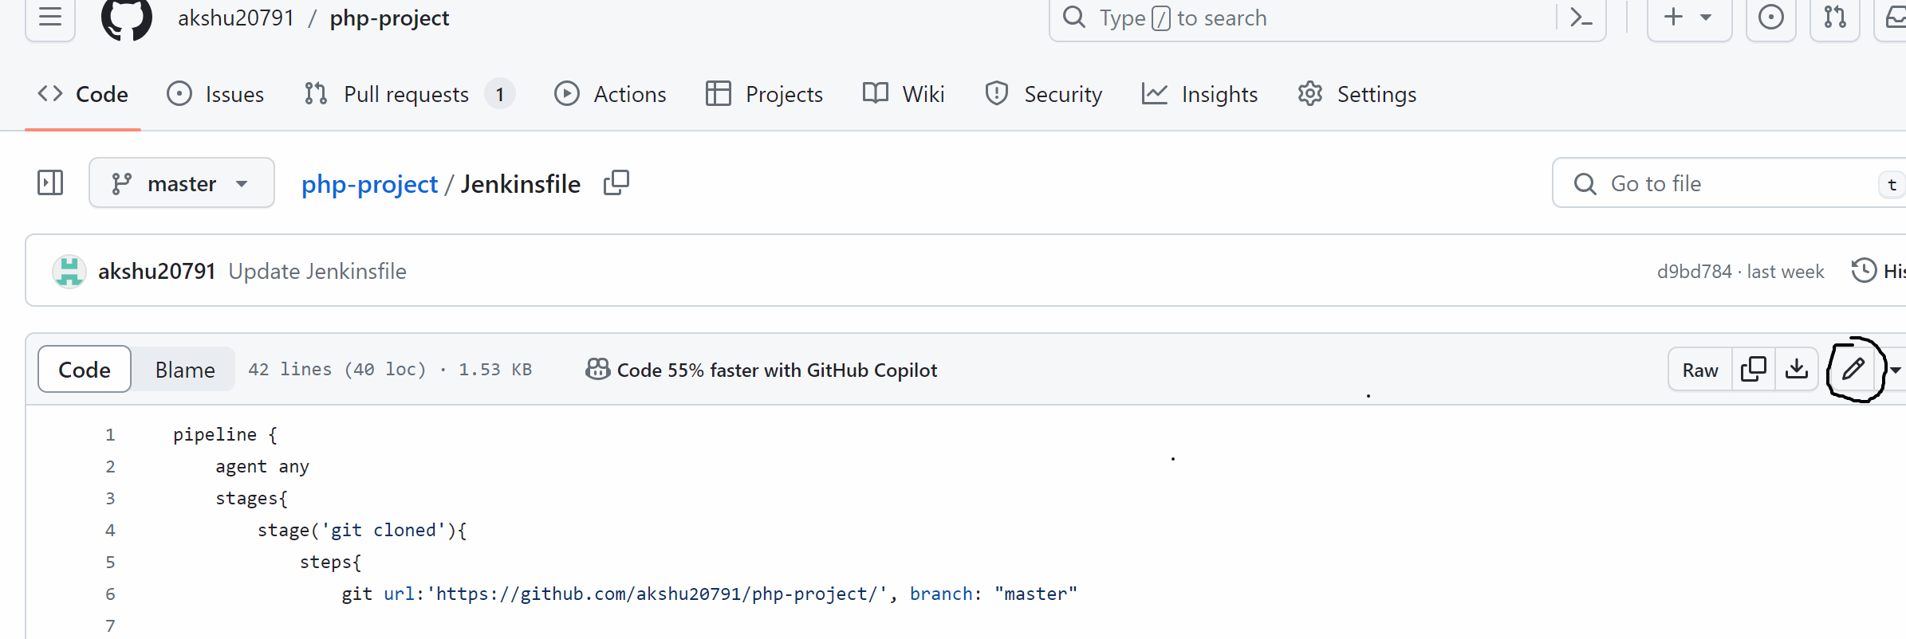

First of all replace the github url in Jenkins file with your github url
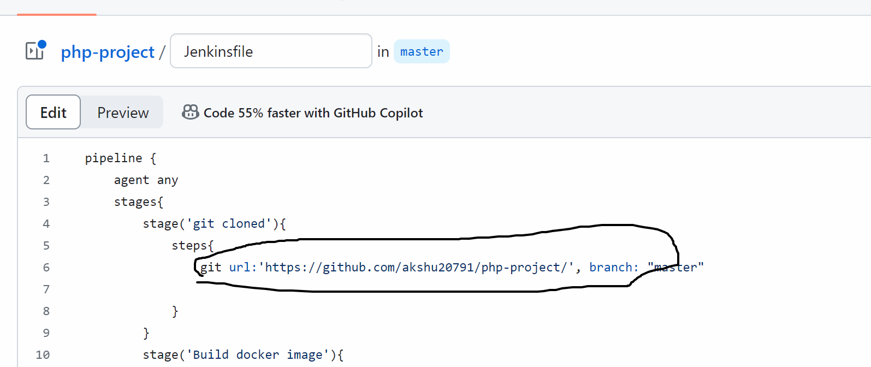

Now in your browser if you don’t have dockerhub id create dockerhuub id from https://hub.docker.com/
(ensure that you don’t login directly via gmail or github …fill the form to create dockerhub account)

In jenkinsfile, replace akshu20791 with your dockerhub username
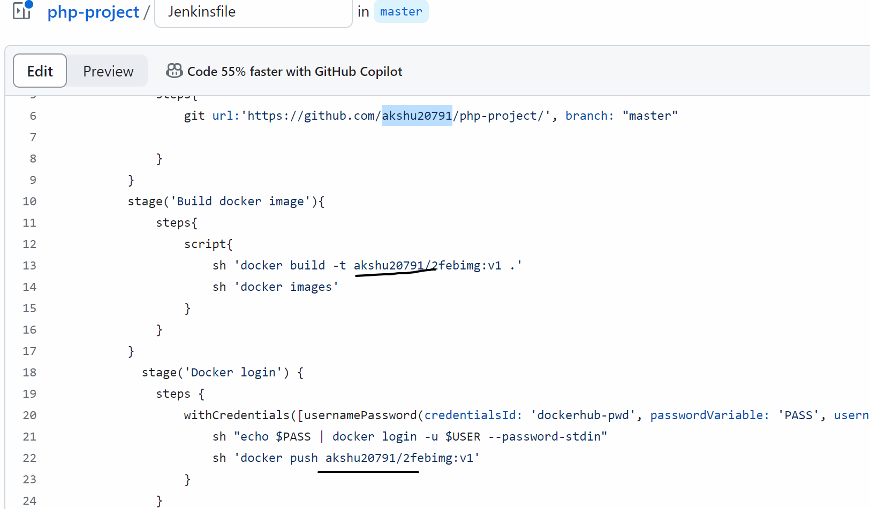

Open aws account -> ec2 -> create 2 ubuntu machine with all traffic enabled

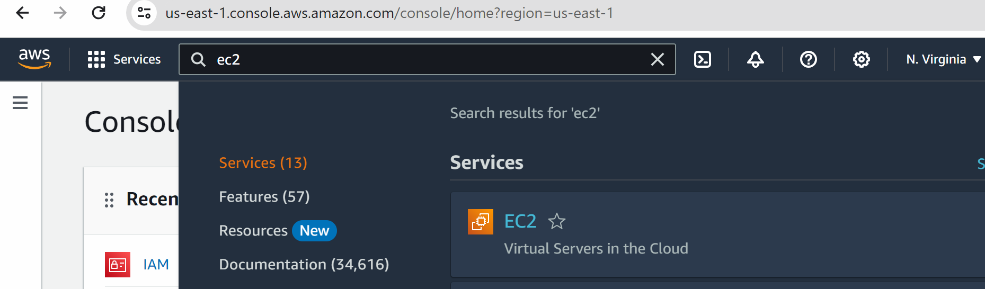

Click on instances -> launch instance
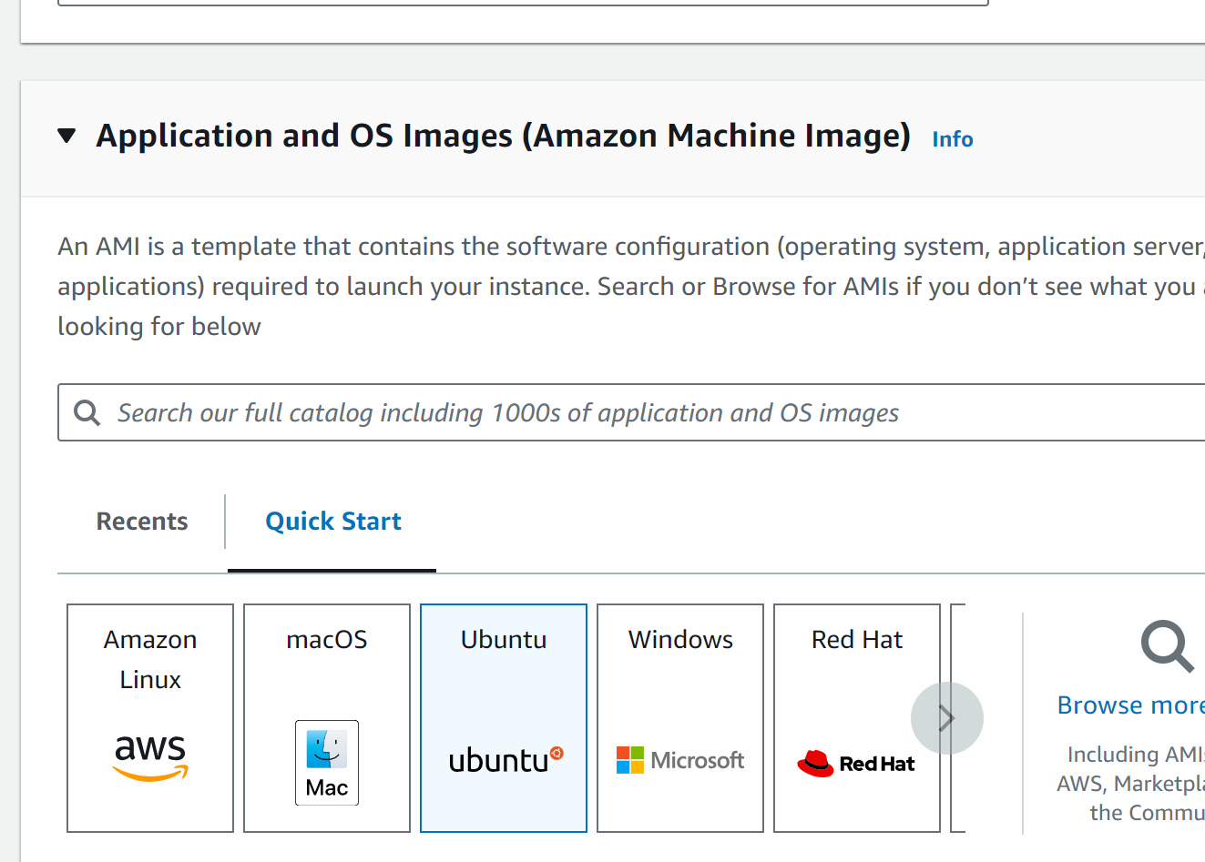

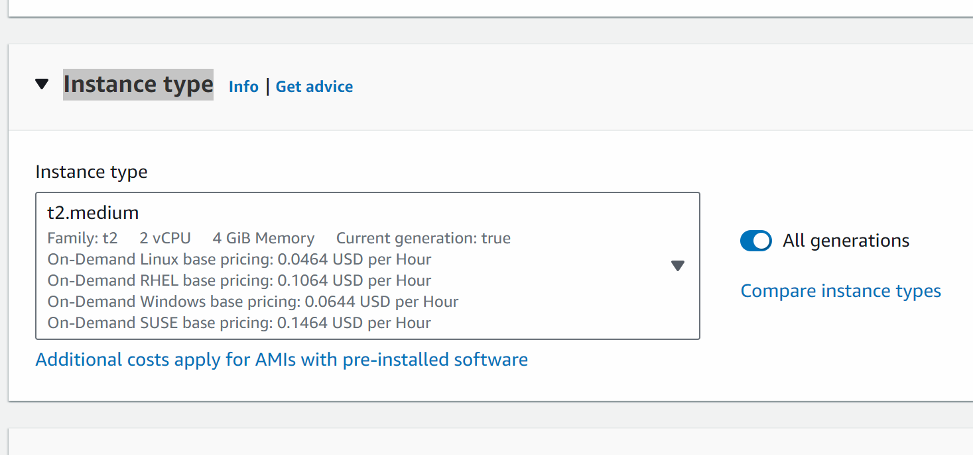
Create new keypair
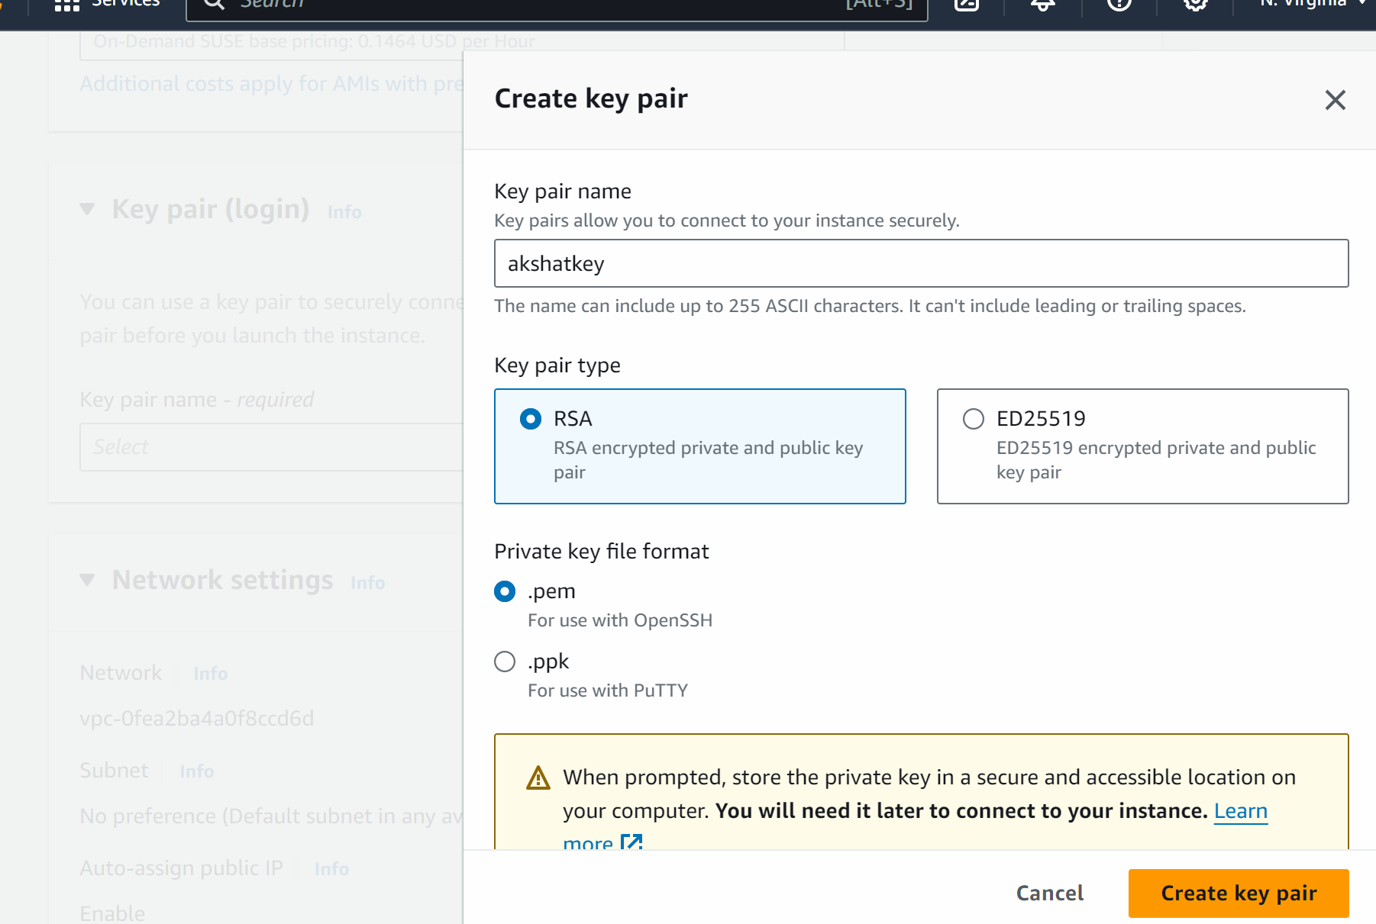
Givename and click on create keypair

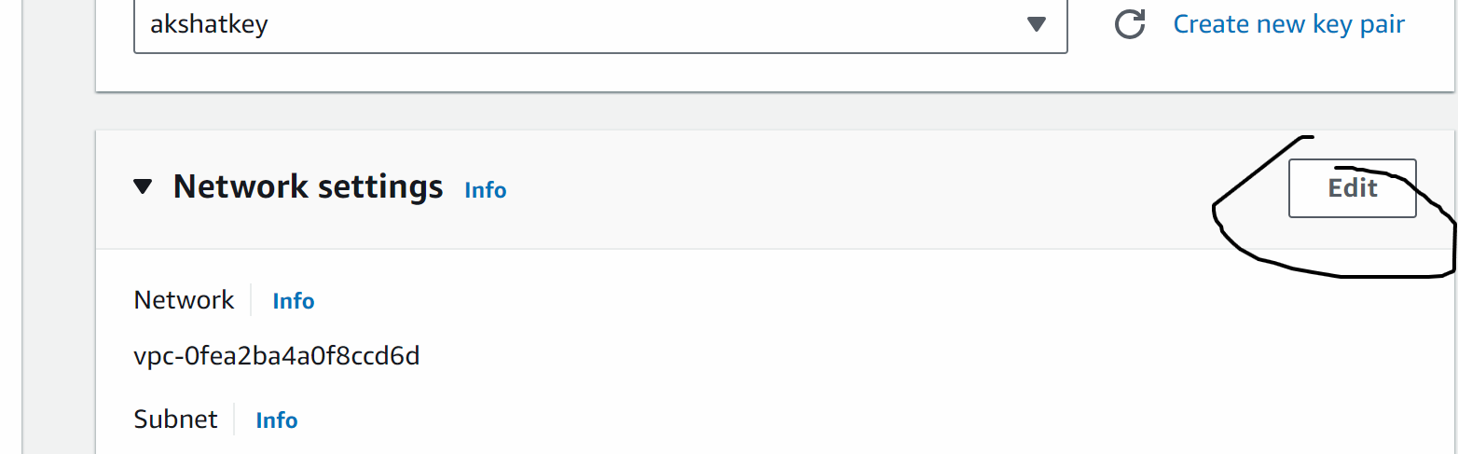

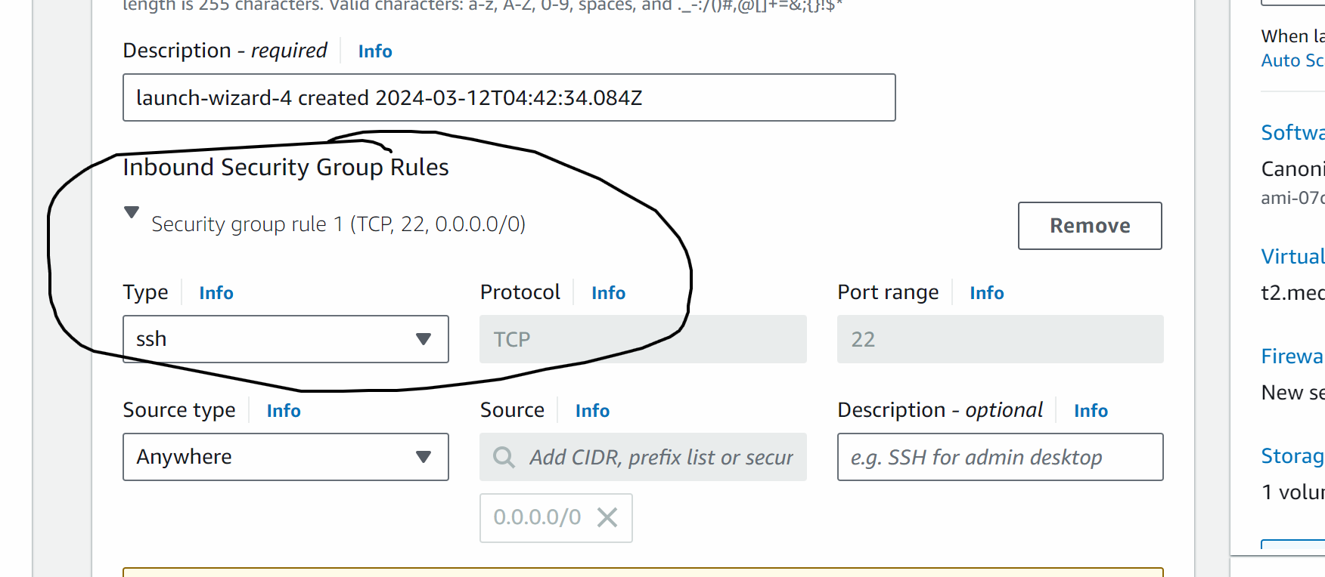
Change type ssh to anywhere
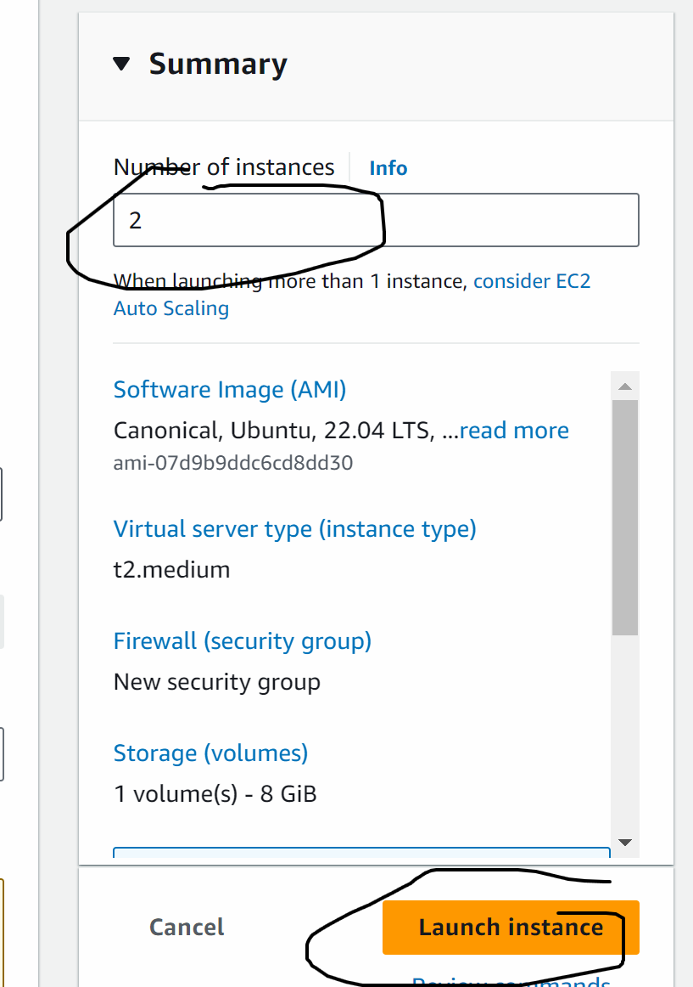

Now you can rename the machine as master-docker and node machine

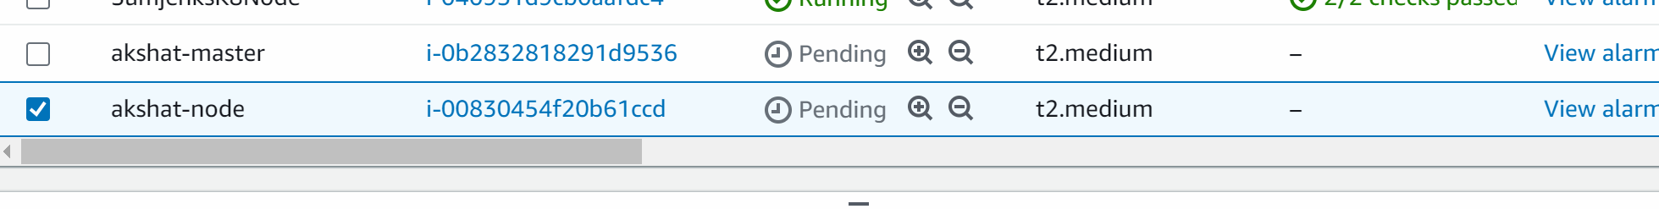

Select the node
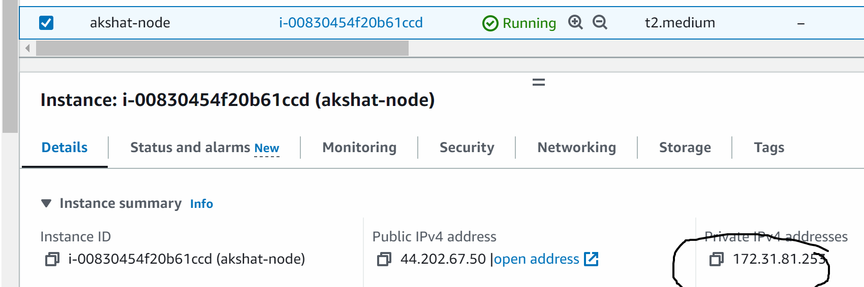
Copy the private ip

Now go back to jenkinsfile in github
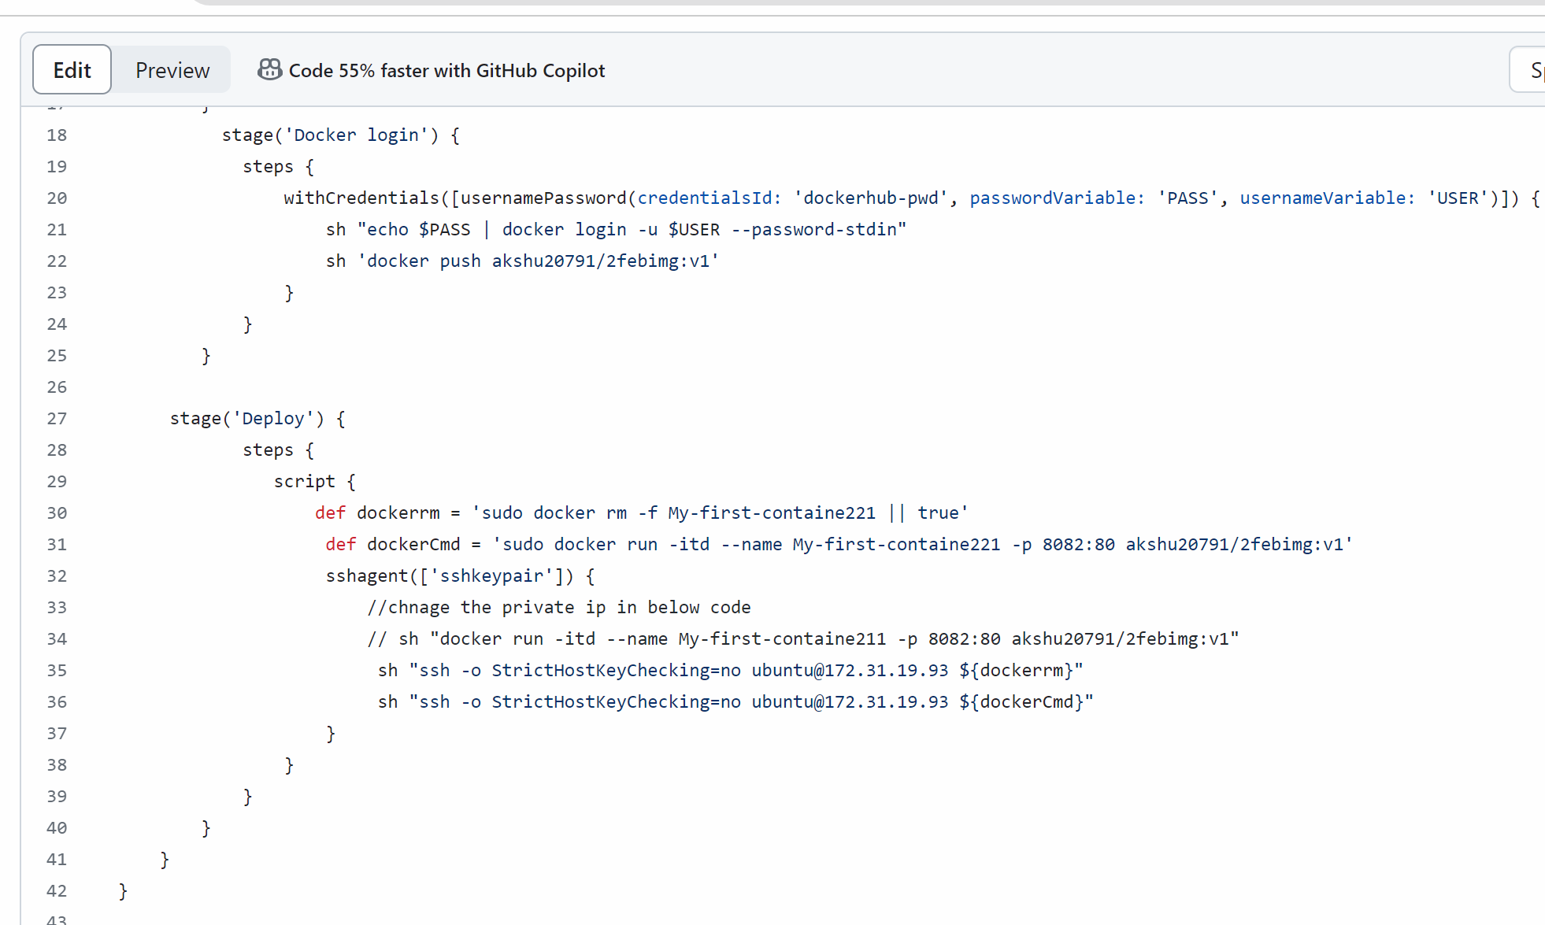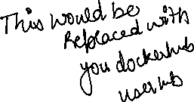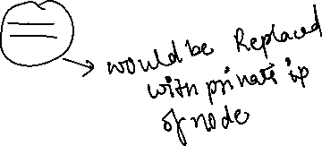

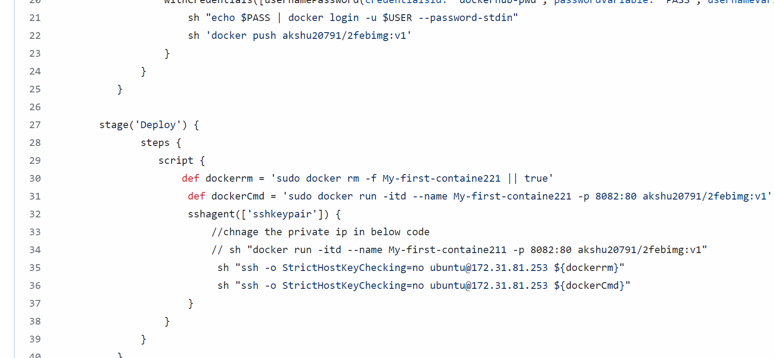

Click on commit to commit the changes you made in jenkinsfile

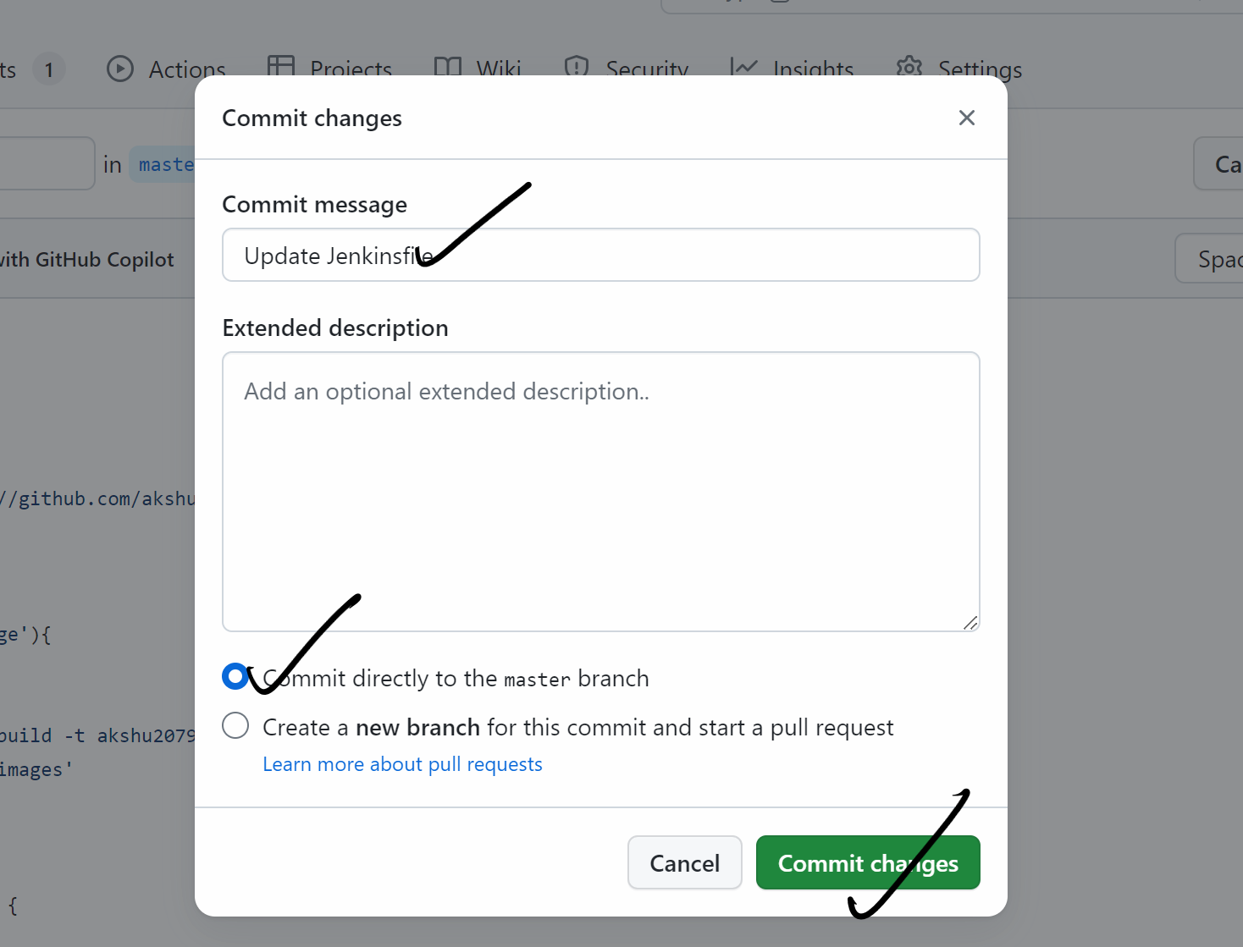

#########################

Go to the master machine and we will install Jenkins and docker in the master machine
Connecting the machine:
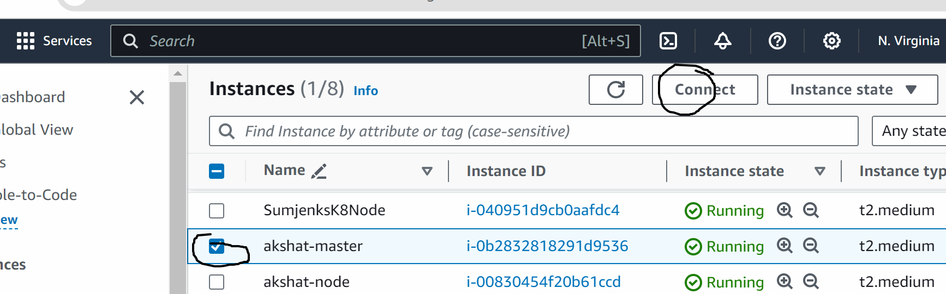

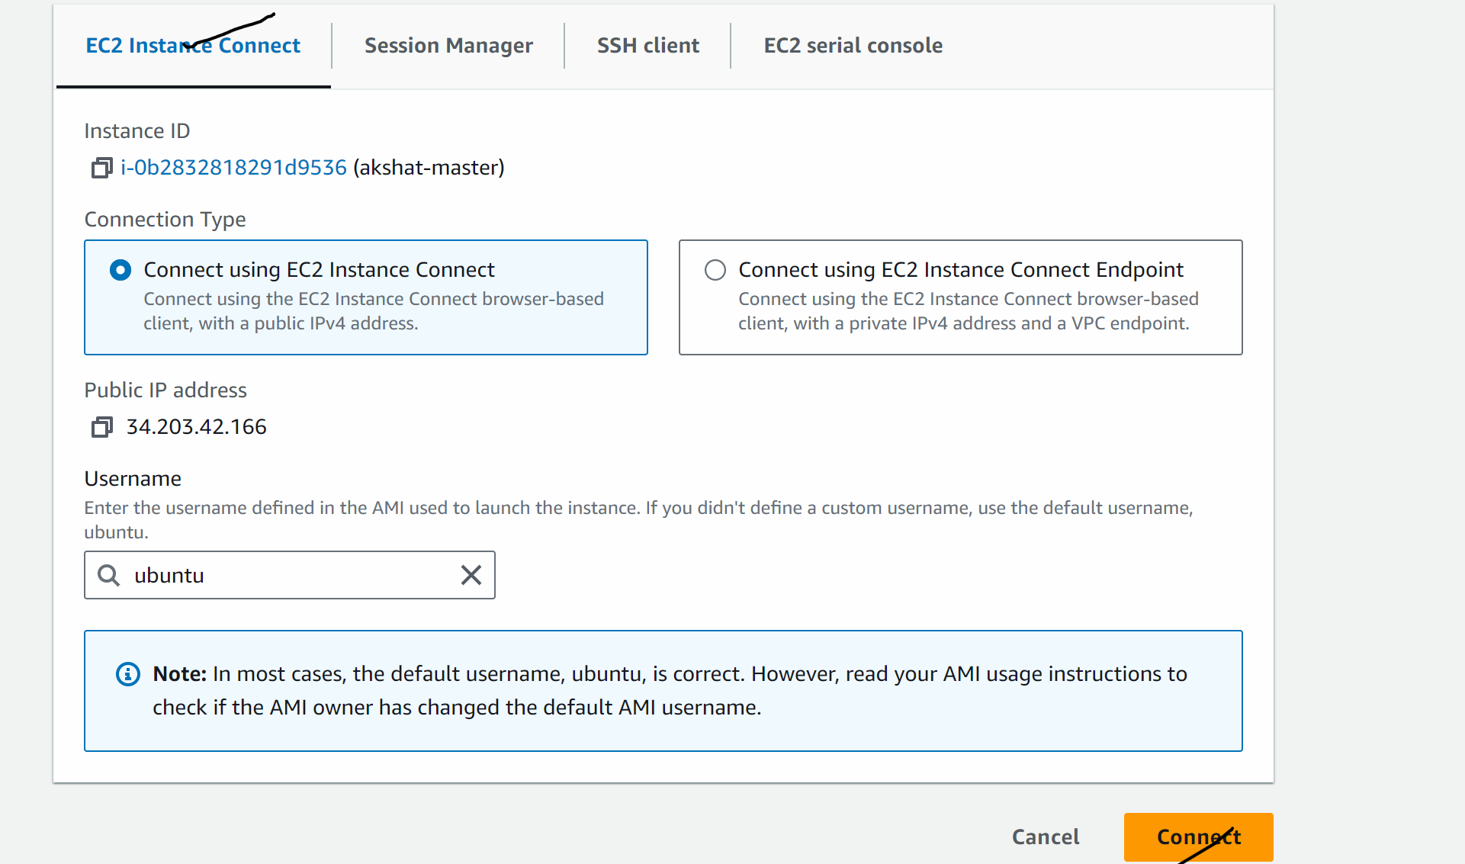

Lets now install Jenkins (follow the way I am doing no changes)

sudo su
wget https://raw.githubusercontent.com/akshu20791/Deployment-script/main/jenkins.sh
ls
chmod 700 jenkins.sh
./jenkins.sh

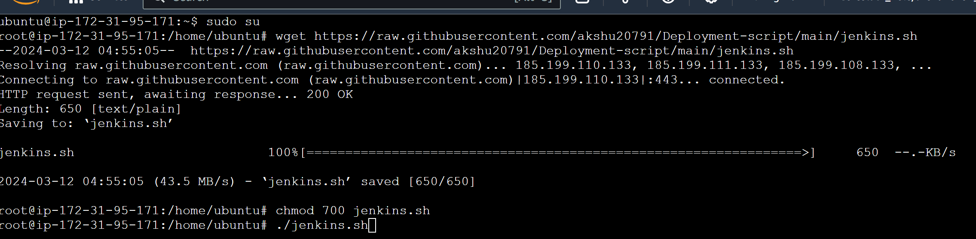

At the a pass will come

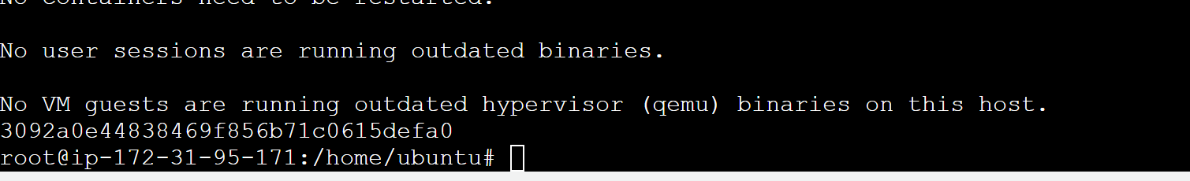

Now copy the public ip of the master machine and open it on port 8080
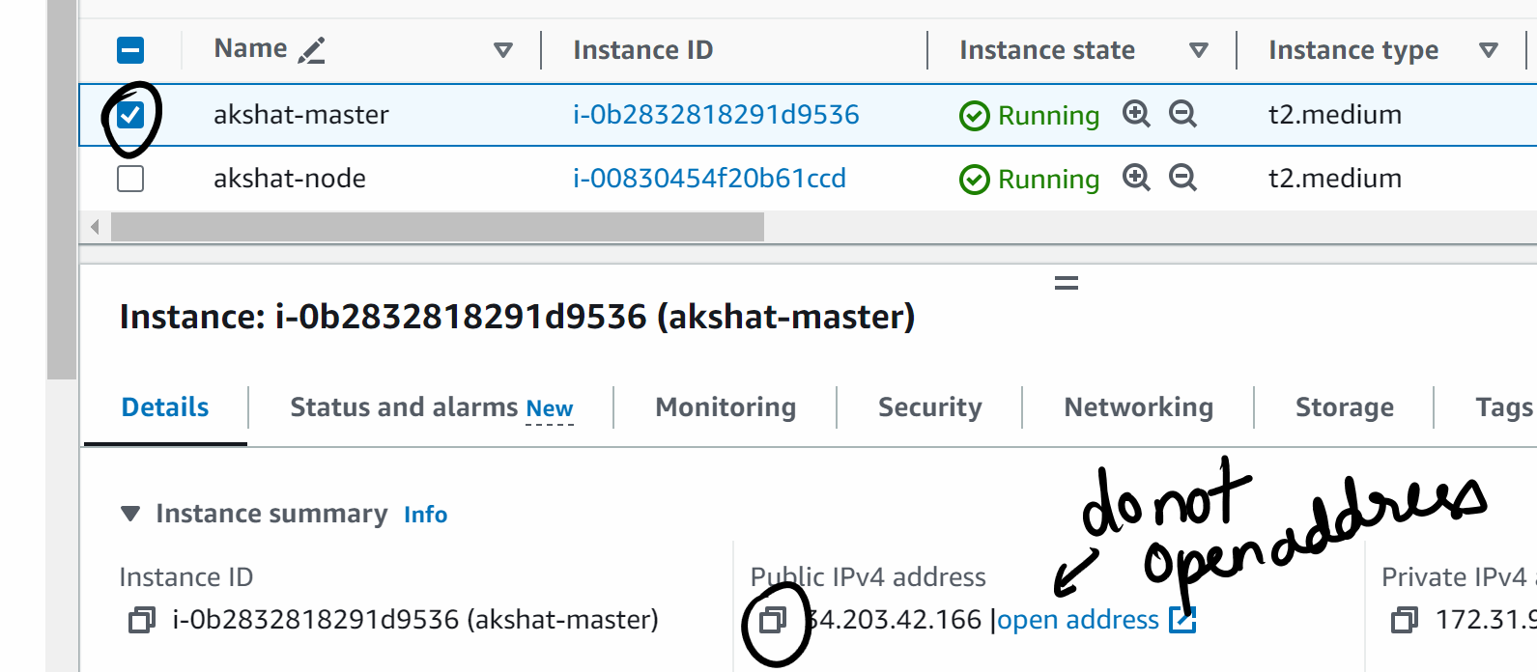

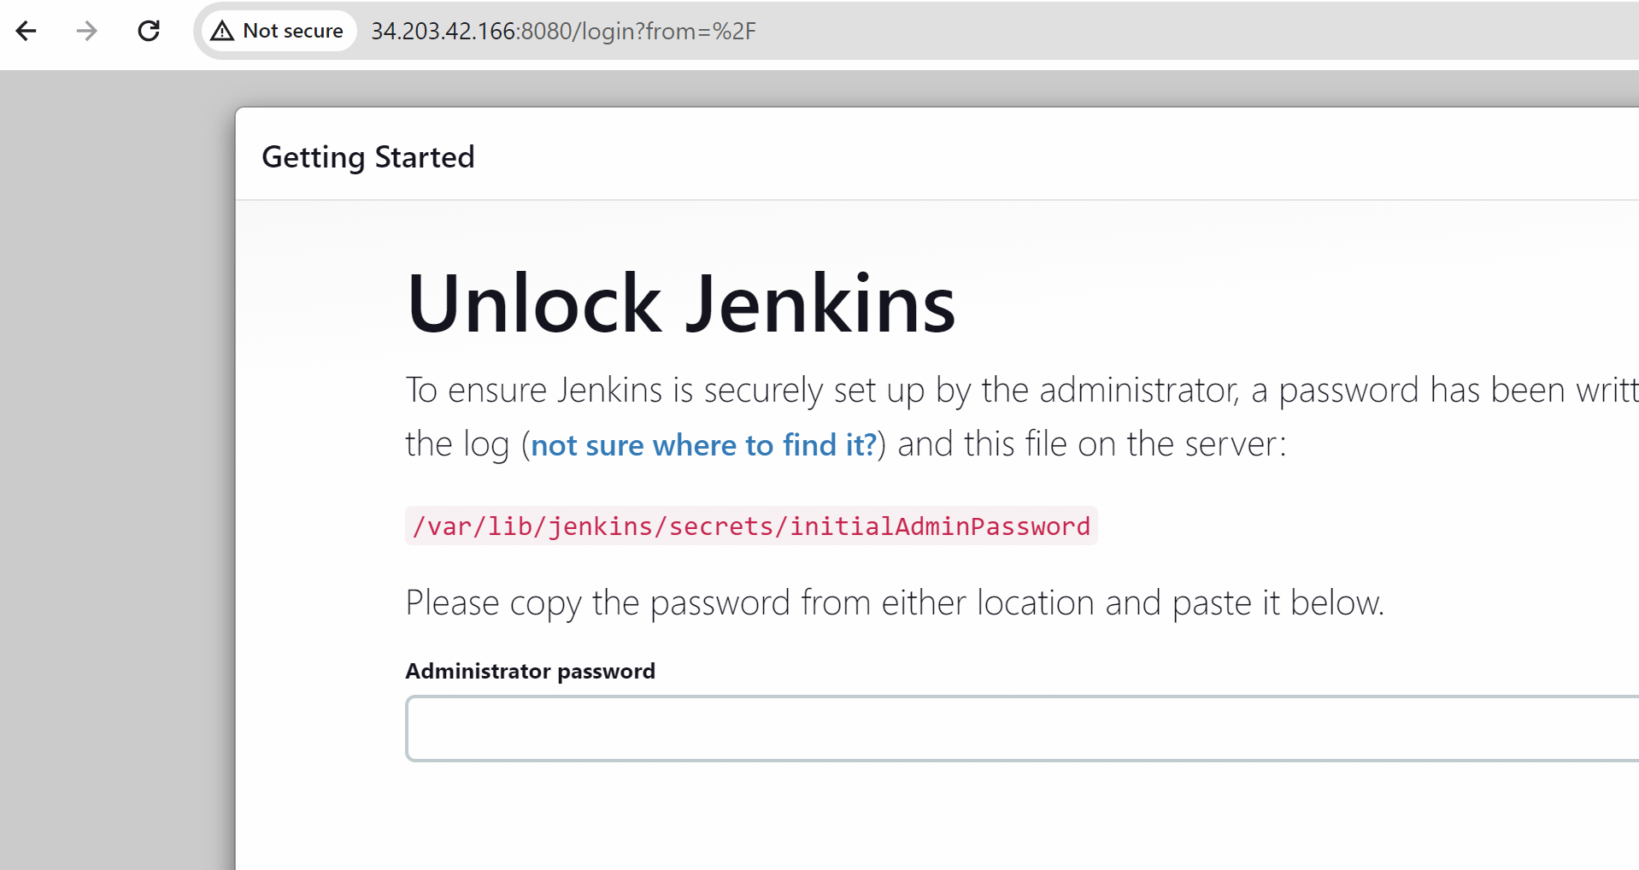
Copy paste the pass which u generated above in administrator pass

Click on continue after pasting the pass
Install suggested plugins
In username passs ….everywhere put admin …in mail put admin@gmail.com

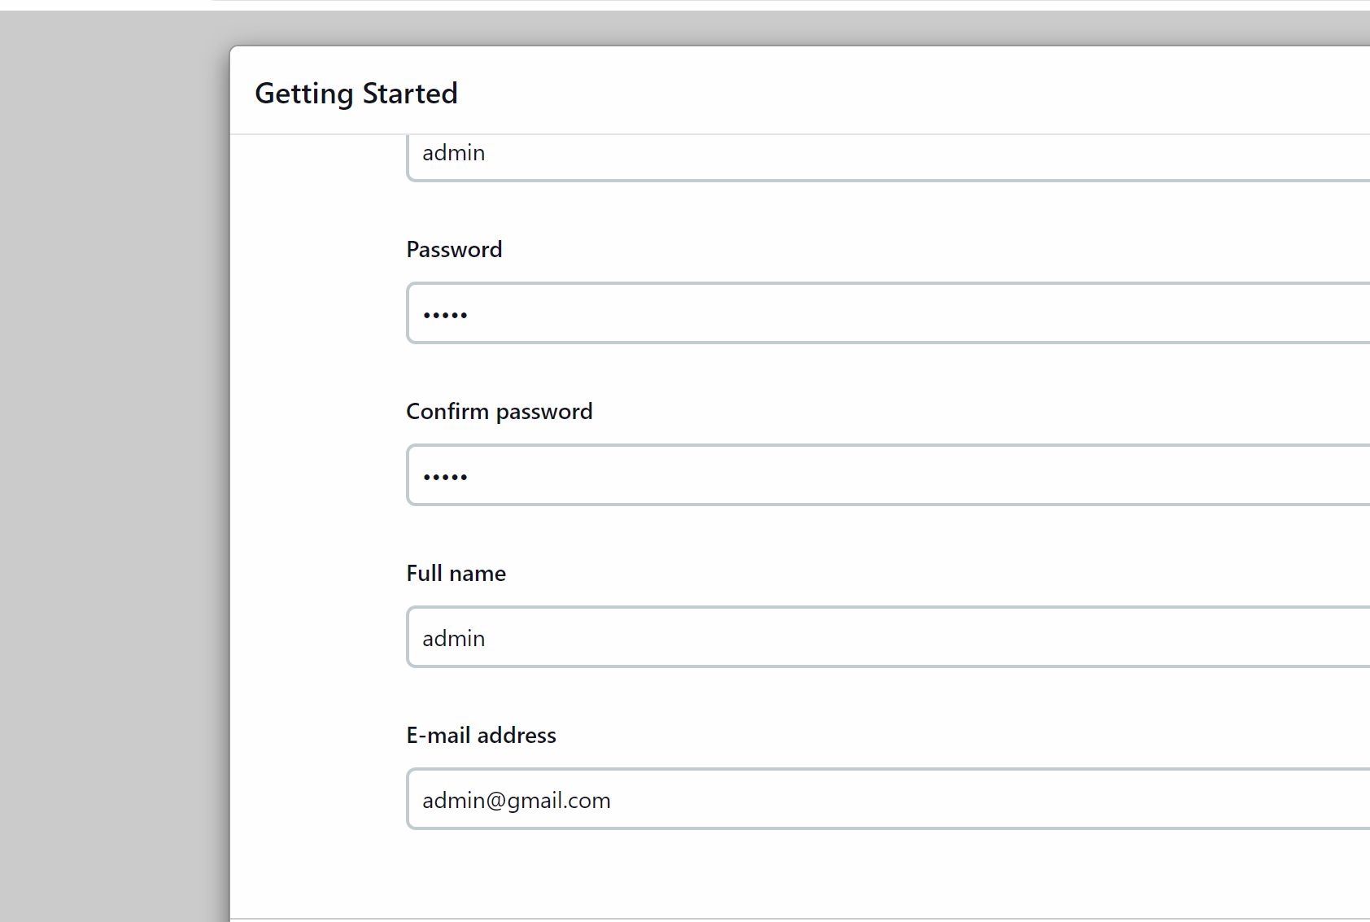

Save and continue
Save and finish
Start using Jenkins

Go to manage Jenkins -> credentials -> click on global

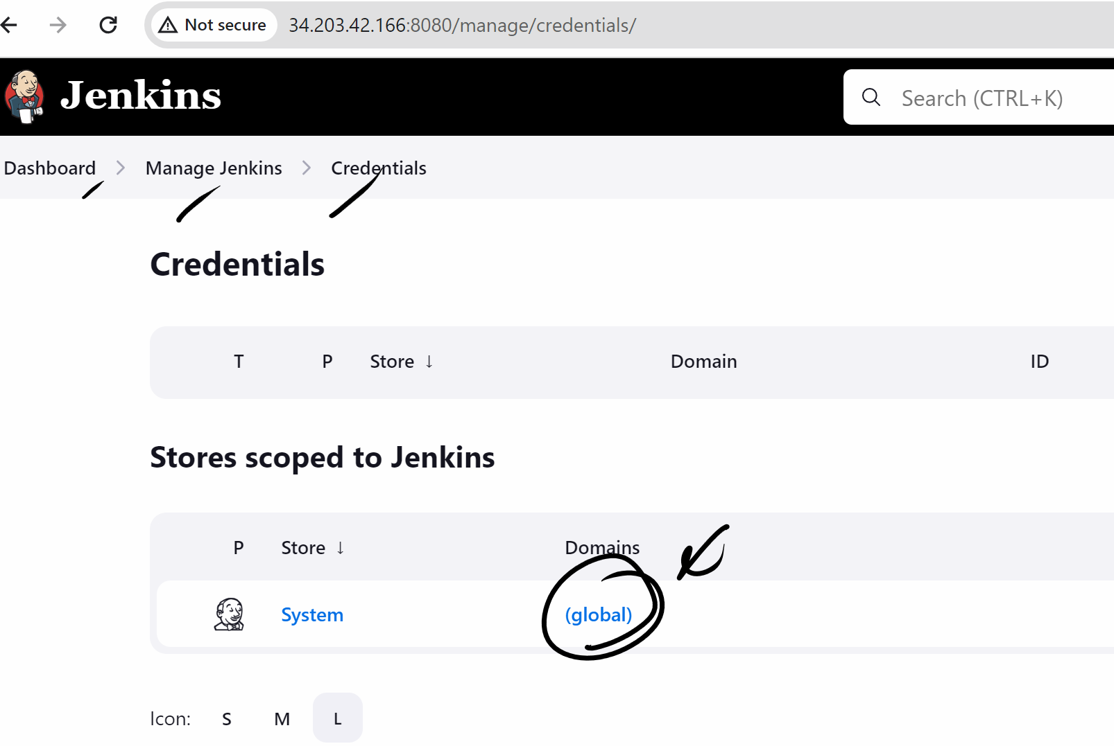

Add credentials button
First we will create dockerhub username and pass creds so that my Jenkins and login and push the image to dockerhub
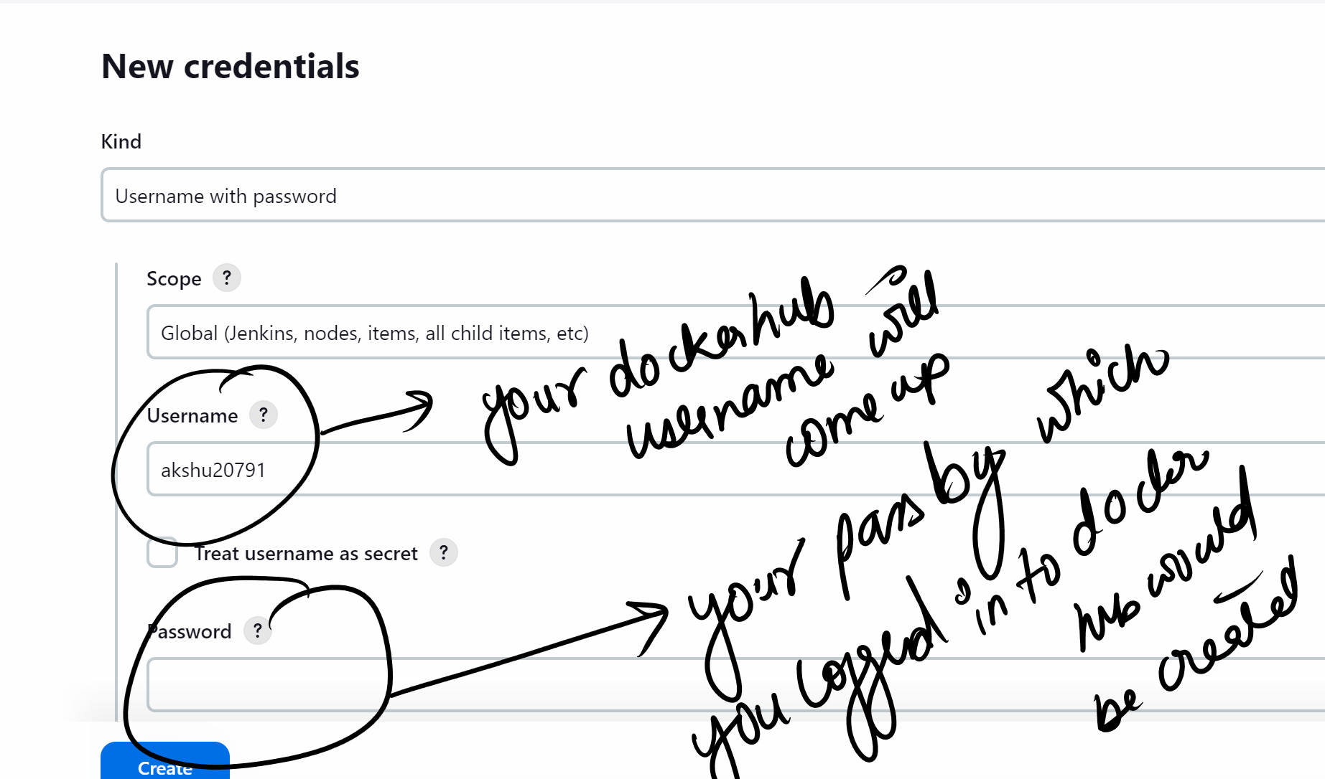

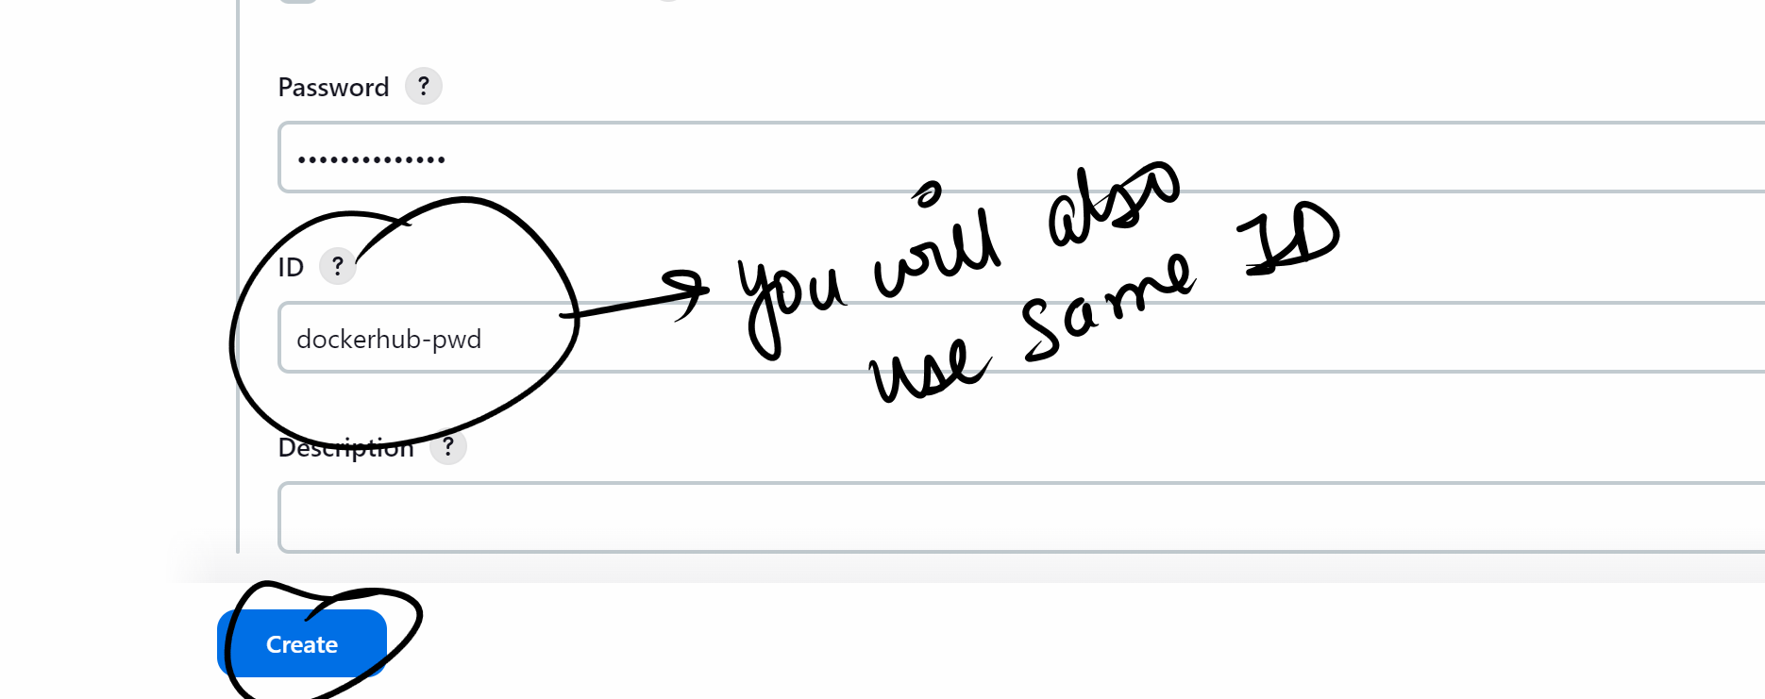

We will create credentials for ssh connection also

Add credemtials
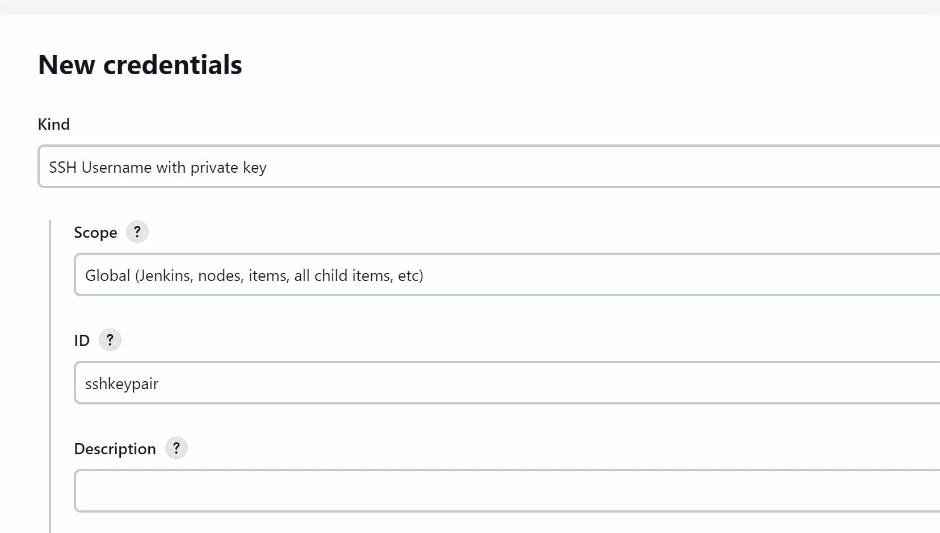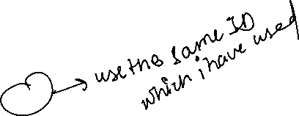

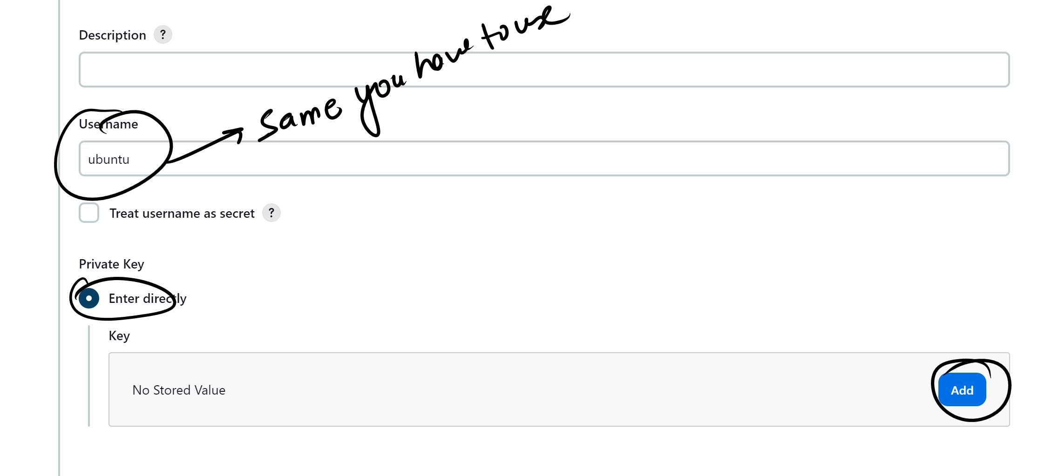

Now check downloads and open the keypair which u created while creating the node ec2 machine..in notepad and copy the whole key
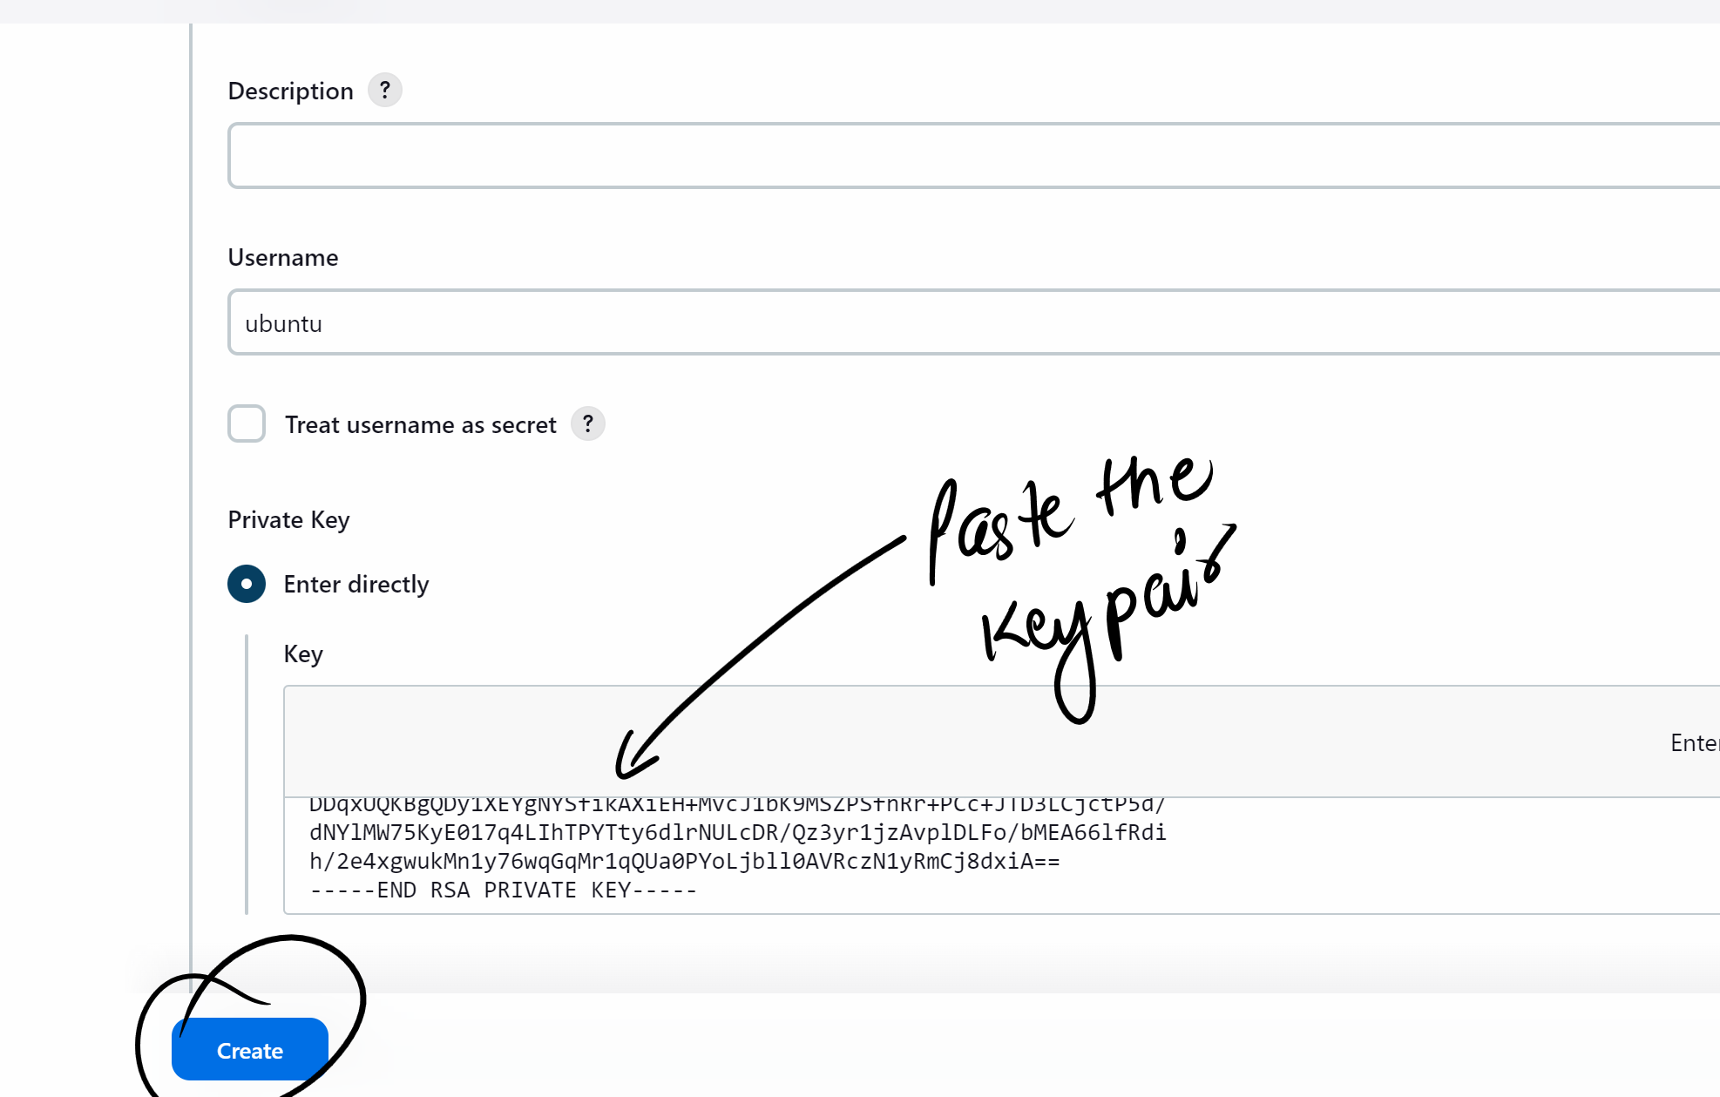

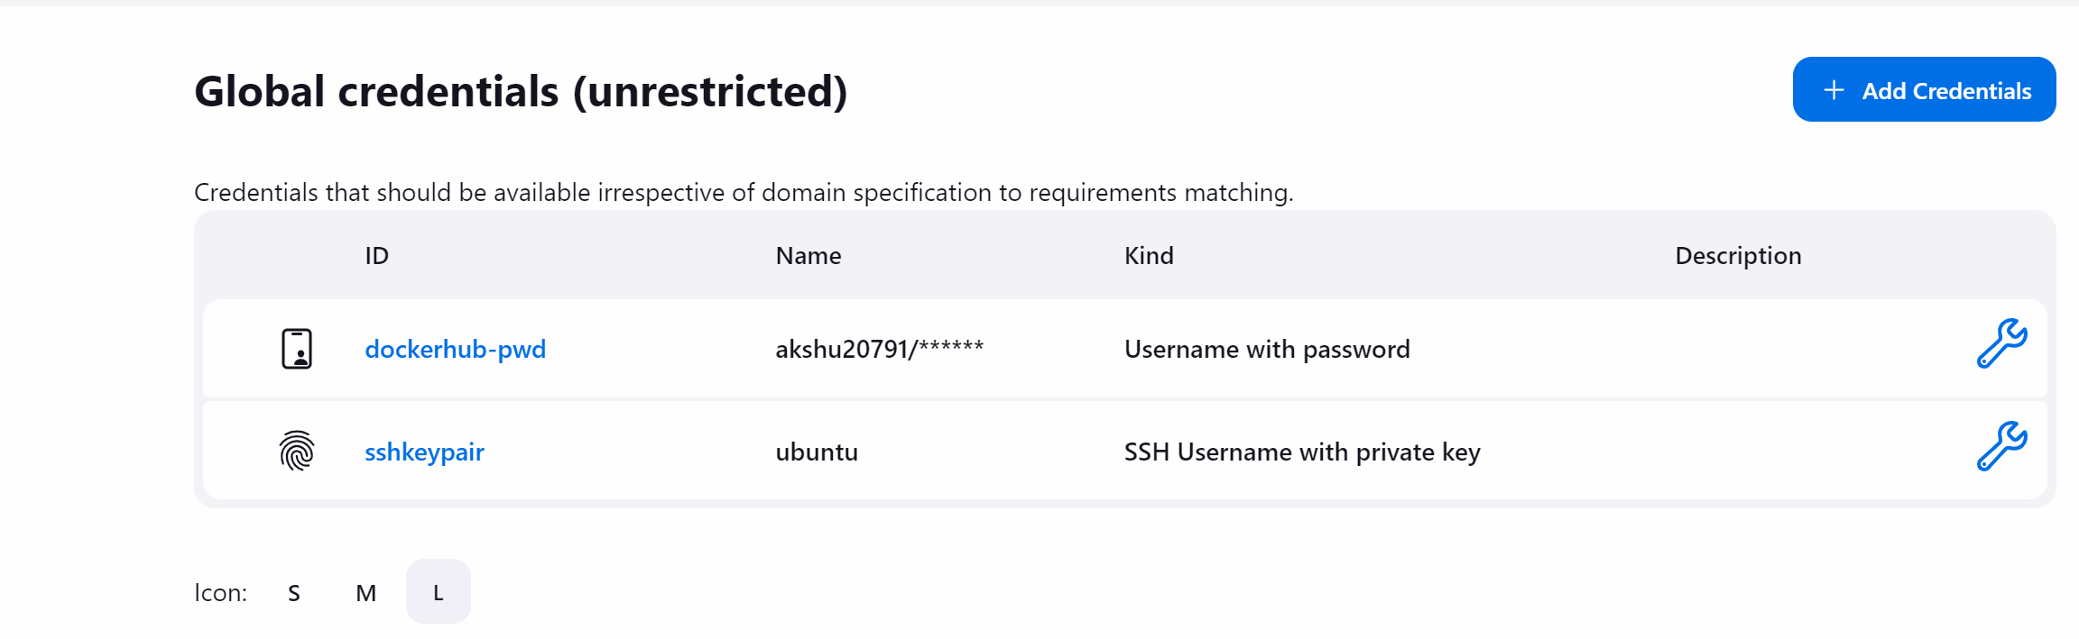
### now we will create pipeline

Go to Jenkins dashboard

+new item
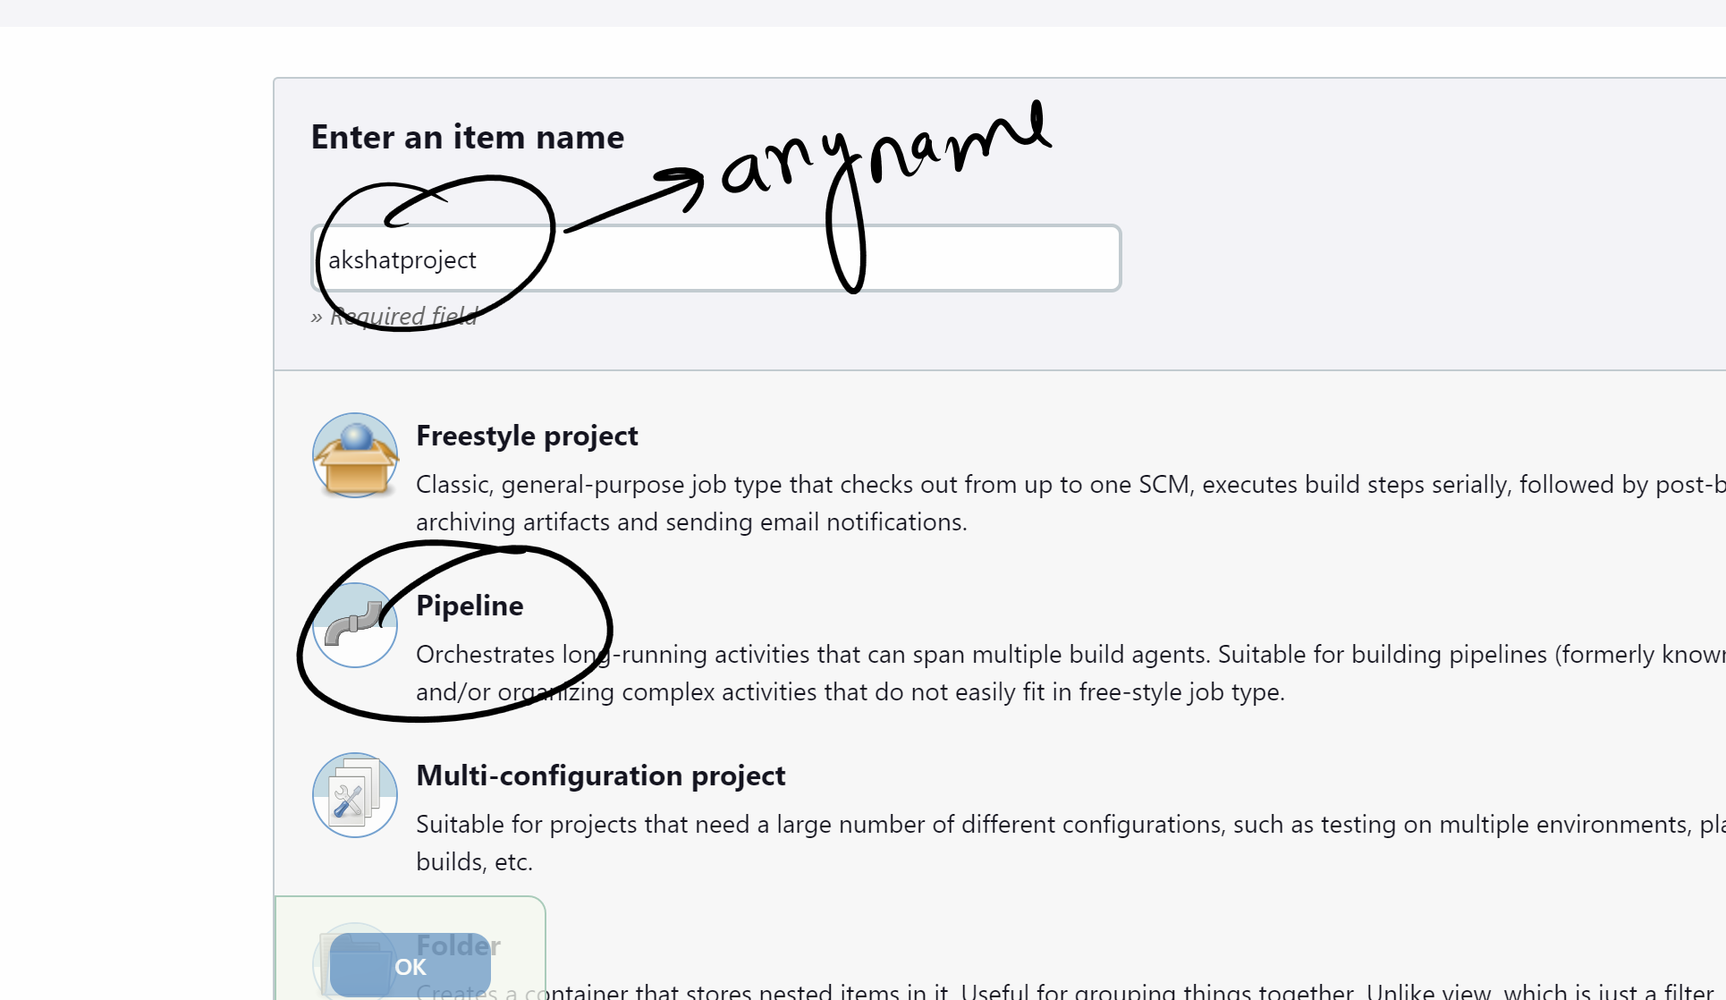

Ok
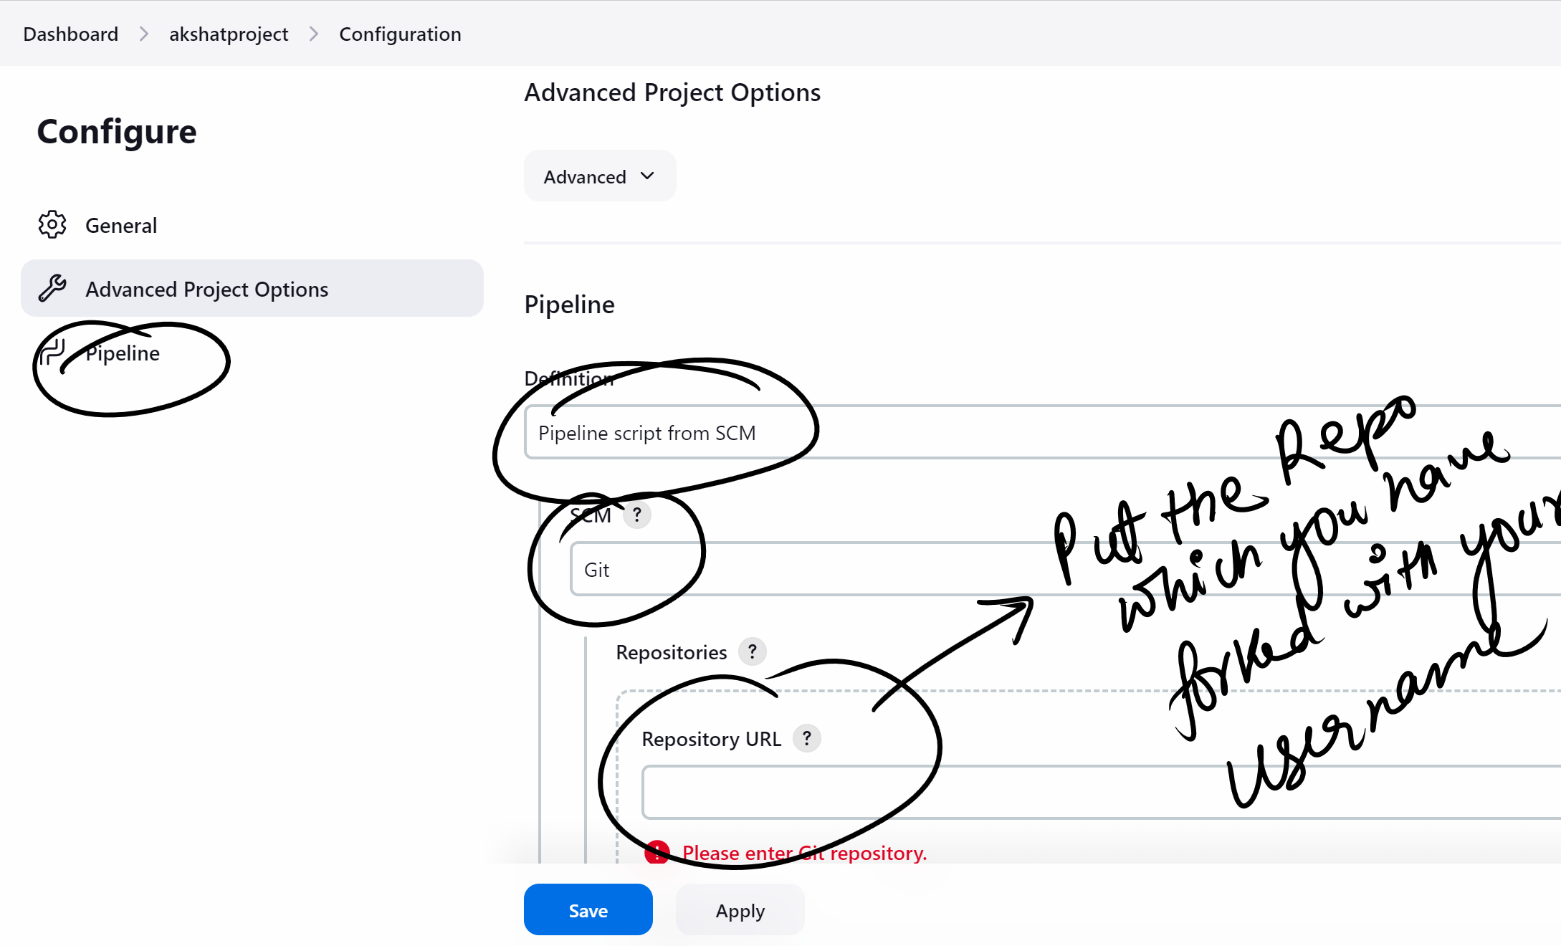
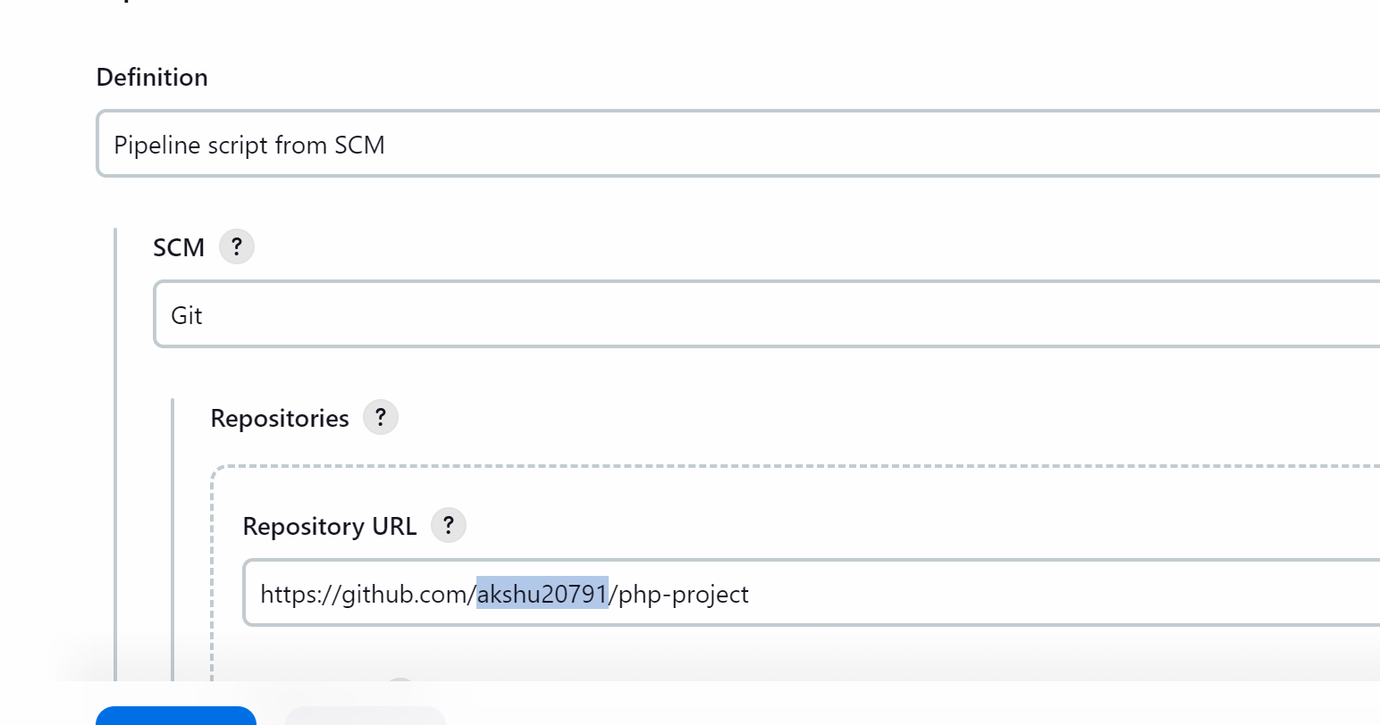Save

########go back to your master machine #########

apt install docker.io -y

service docker start


Now we will give the access to jenkisn user to access docker user
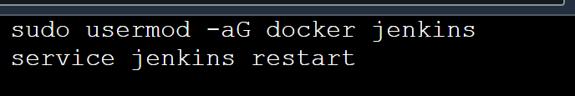

sudo usermod -aG docker jenkins

service jenkins restart
################################################
Get into the node
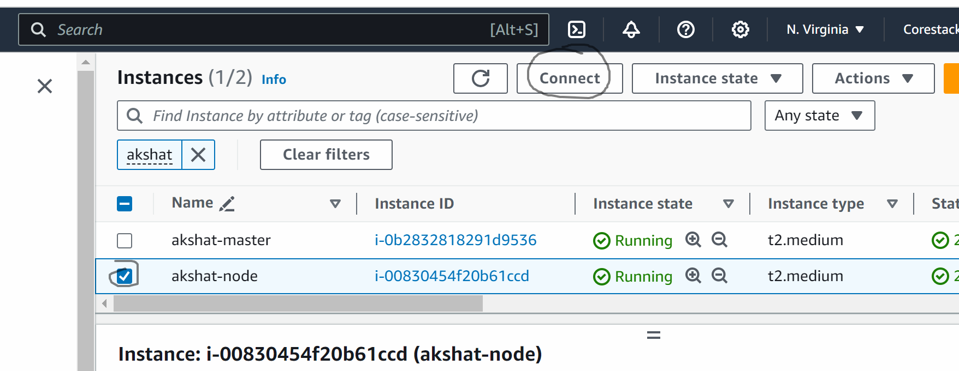

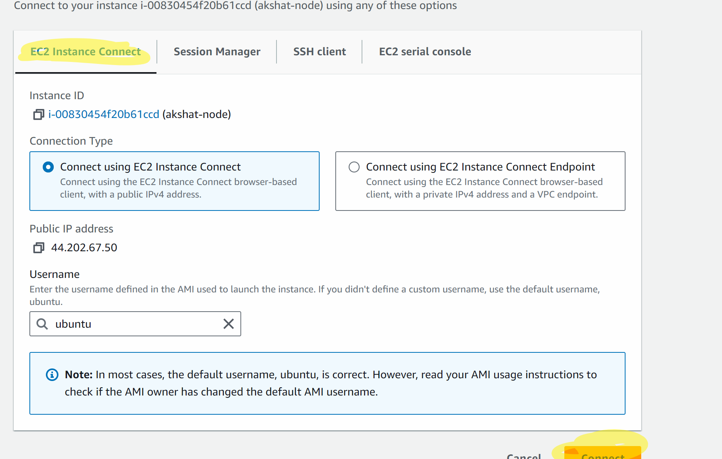
sudo su
apt update -y
apt install docker.io -y
service docker start

go to Jenkins and refresh the browser
Relogin
Go to Jenkins dashboard
Go to manage Jenkins -> plugins -> available plugins
Search for docker
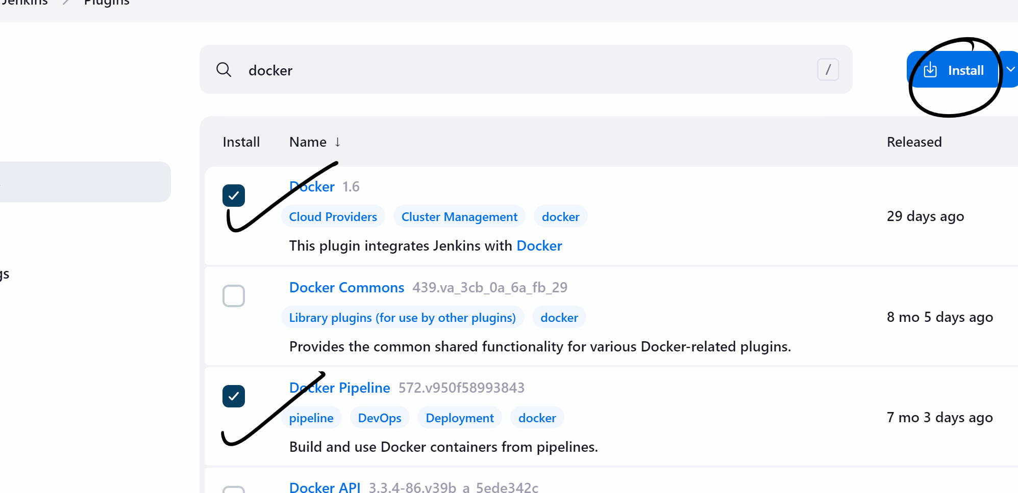

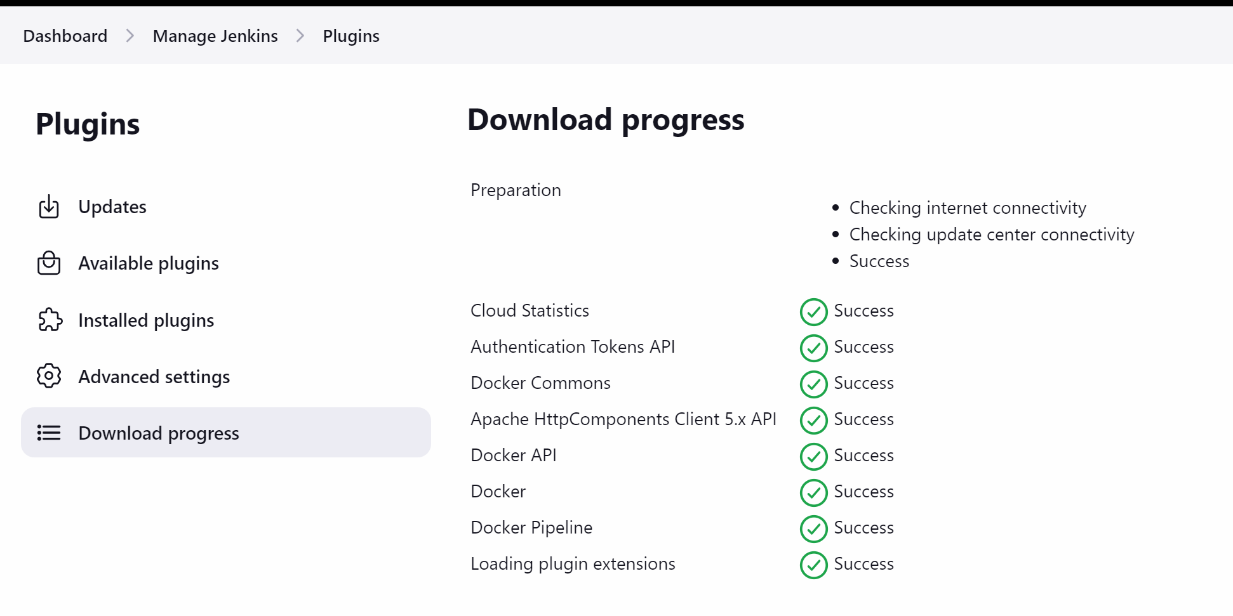

Now again click on available plugin

Search ssh
Install ssh agent plugin
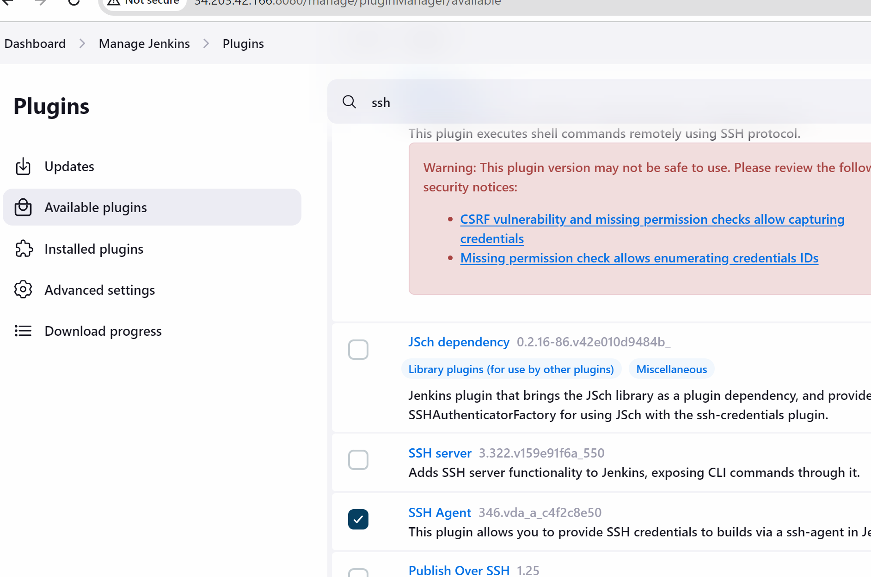

Click on install

Go back to dashboard

Click on project
And build the project
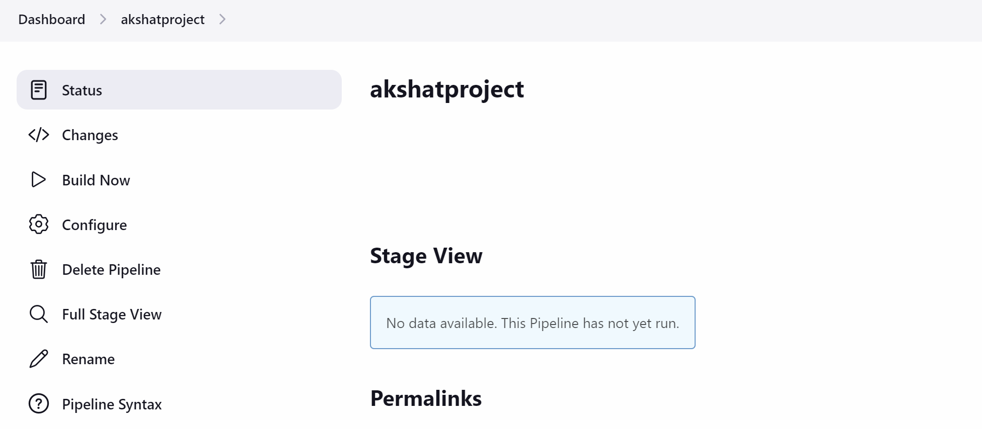

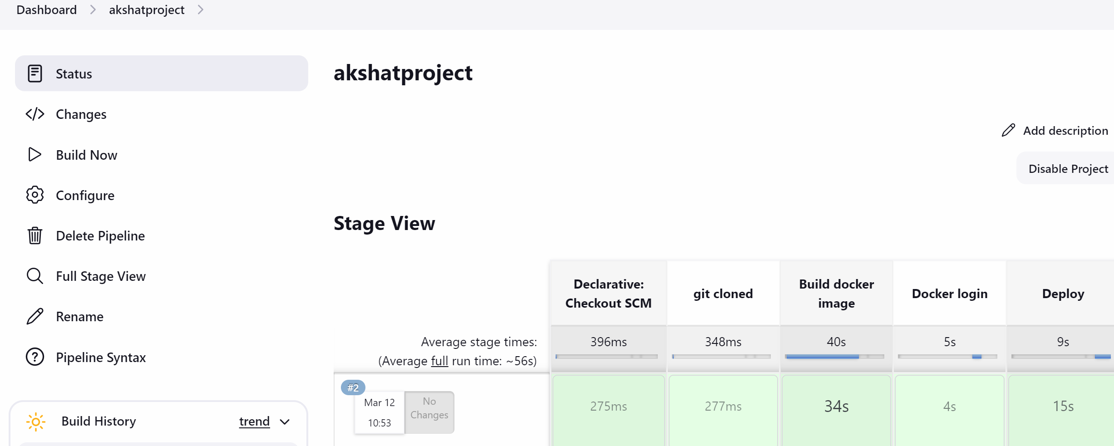

Go to aws …copy the node public ip address ….
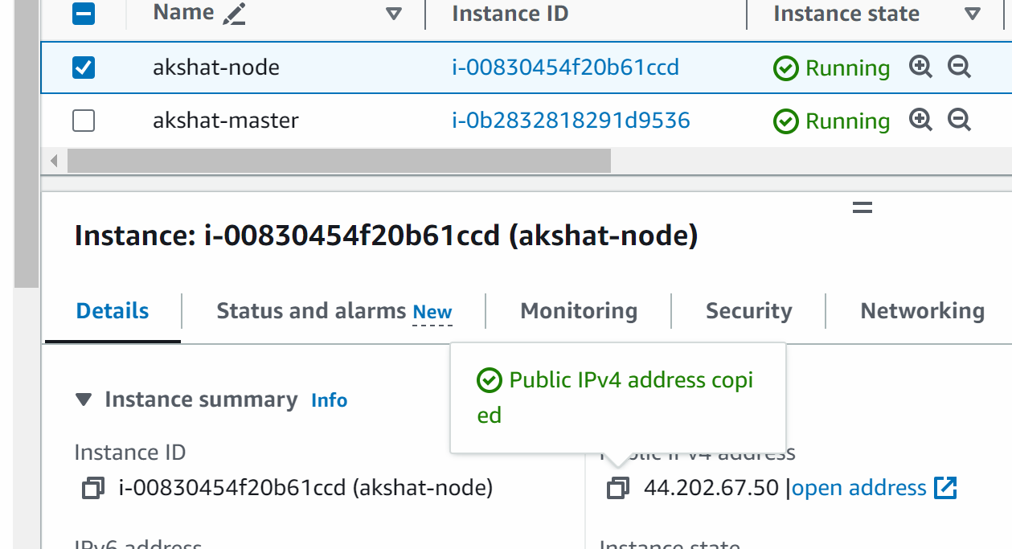
<publicipofmachinewheredeploymenthappened>:8083
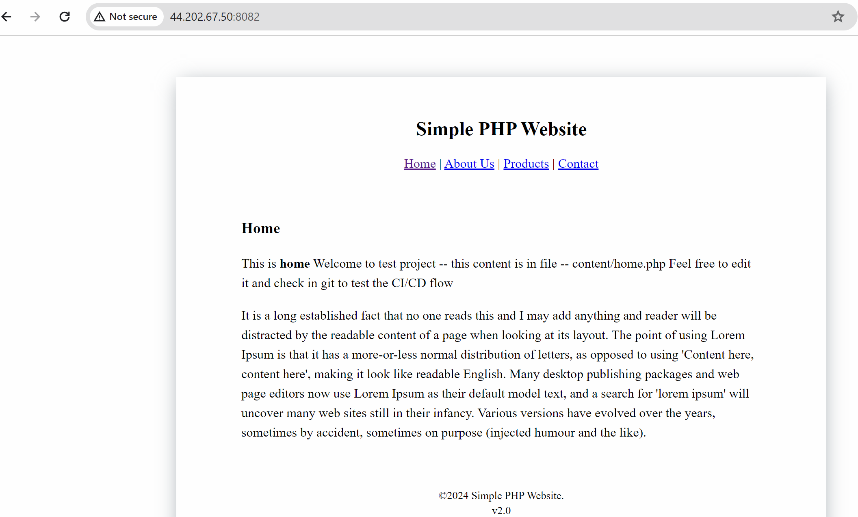

App is running

